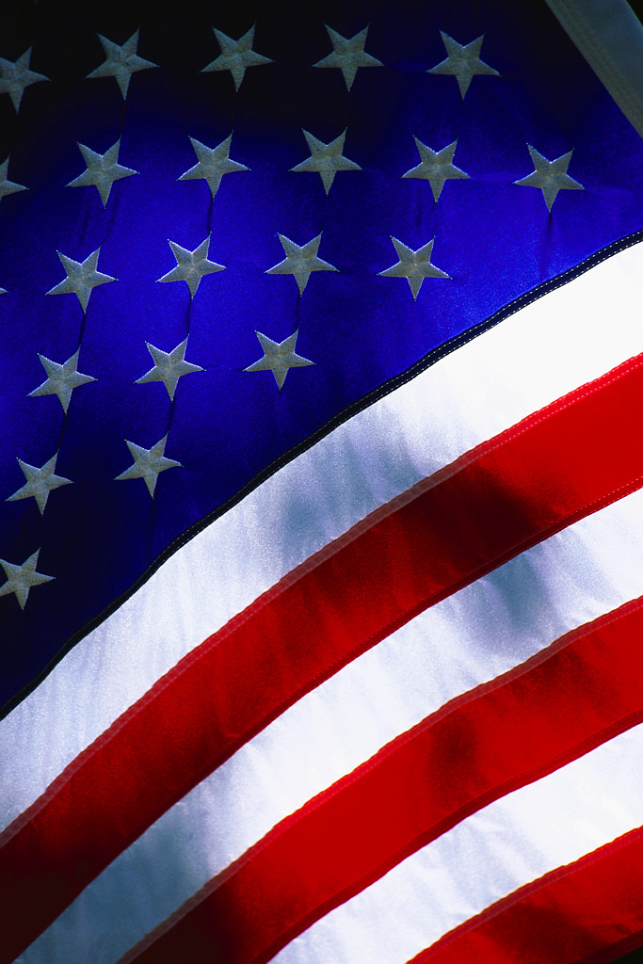
University Compliance & Integrity
SAVE THE DATE!
EXPORT CONTROLS TRAINING SESSIONS WITH NELSON PEREZ
April 24th, 25th , 26th & 27th, 2017

Live Export Control Training:
The Office of University Compliance & Integrity is holding live training sessions for Export Controls on the following dates and times:
- Operational & Administrative Session (for University personnel who have exposure or responsibilities related to Export Controls)
- April 25, 2017 (Tuesday) 10 am to 12 pm Room GC-316

- General Research Session (for Faculty & Staff who are involved in research)
- April 24, 2017 (Monday) 10 am to 12 pm Room EC-2300
- April 26, 2017 (Wednesday) 10 am to 12 pm Room GC 314

- Medical and Health Sciences Field Session (for those in Medical & Health Sciences who may be exposed to or have responsibilities related to Export Controls)
- April 27, 2017 (Thursday) 10 am to 12 pm Room GC-316
Why is it Critical to Attend?
- To avoid liability for violations (which include substantial civil and criminal monetary penalties and sanctions) that can be enforced at both the individual and institutional levels
- To help minimize personal and institutional risk through awareness

You will earn 2 hours of Professional Development Credit for attending.
Refreshments will be provided.
*Please register to attend any of the session(s) through Human Resources at: https://professionaldevelopment.fiu.edu/ Select University Compliance Office

