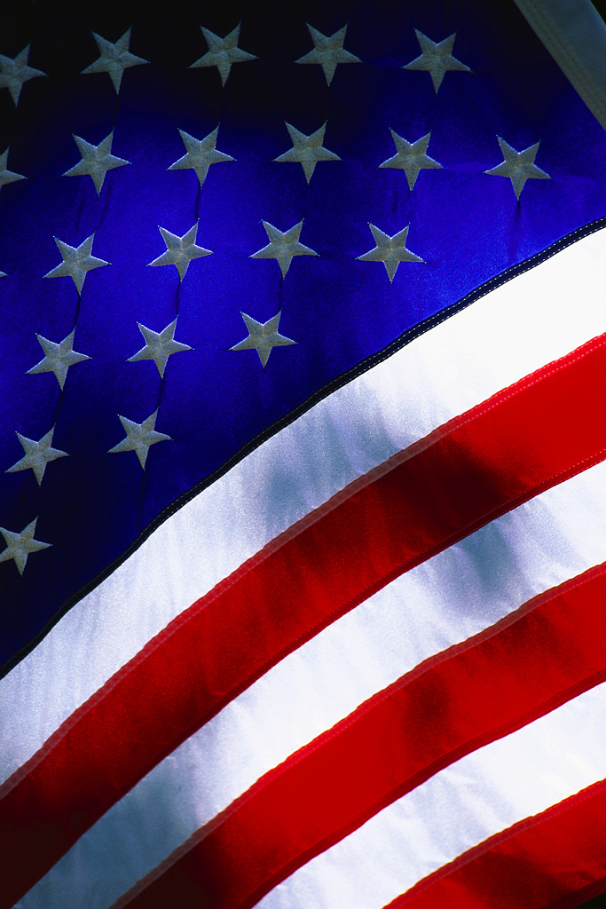
University Compliance & Integrity
SAVE THE DATE!
EXPORT CONTROL TRAINING SESSIONS WITH NELSON PEREZ
April 25th, 26th & 27th, 2017

Live Export Control Training:
The Office of University Compliance & Integrity is holding live training sessions for Export Controls on the following dates and times:
- Operational & Administrative Session (For University personnel who have exposure or responsibilities related to Export controls)
- April 25, 2017 (Tuesday) 10 am to 12 pm Room GC-316

- General Research Session (For Faculty & Staff who are involved in research)
- April 26, 2017 (Wednesday) 10 am to 12 pm Room GC-314

- Medical and Health Sciences field Session (For those in Medical & Health Sciences who may be exposed to or have responsibilities related to Export Controls)
- April 27, 2017 (Thursday) 10 am to 12 pm Room GC-316
Why is it Critical to Attend?
- To avoid liability for violations (which include substantial civil and criminal monetary penalties and sanctions) can be enforced at both the individual and institutional levels
- To help minimize personal and institutional risk through awareness
- Refreshments will be provided and you will earn 2 hours of Professional Development Credit for attending
*Please register to attend any of the session(s) through Human Resources at: https://professionaldevelopment.fiu.edu/ Select University Compliance Office

