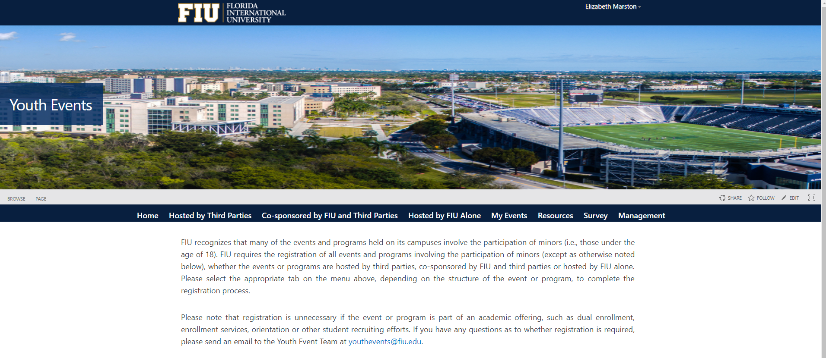
The Youth Events Website can be found at youthevents.fiu.edu.
Questions can be sent to youthevents@fiu.edu.

